|  |
| --- |
| Technical Design (TD) & Configuration Specification (CS) |
| **System Name** |
| **Release** X.Y.Z |
| **Document Version:** X.0 |
| Issue Date: DD-Mmm-YYYY |
| The Issue Date is the date that the final version of this document was ready for signature. |

**Author**

|  |
| --- |
| ***Role:*** *Technical Owner or Designee* |
|  |
| *(Name (if not Adobe sign) / Title / Company)* ***Date*** |
|  |

**Approval**

|  |
| --- |
| ***Role:*** *Technical Unit* |
|  |
| *(Name (if not Adobe sign) / Title / Company)* ***Date*** |
|  |

|  |
| --- |
| ***Role:*** *Validation Unit* |
|  |
| *(Name (if not Adobe sign) / Title / Company)* ***Date*** |
|  |

|  |
| --- |
| ***Role:*** *Approver* |
|  |
| *(Name (if not Adobe sign) / Title / Company)* ***Date*** |
|  |

In addition to the approvers listed above this document was reviewed and comments provided by:

[Name, Title, Company]

**Delete this section if no other parties were involved.**

|  |  |  |
| --- | --- | --- |
| **Revision History** | | |
| **Document Version** | **Issue Date *(dd-MMM-YYYY)*** | **Reason for Update** |
| X.0 [Version #] | [Date the final version is released for signature] | [Initial Version or Describe in Detail the sections or paragraphs updated] |
|  |  |  |

|  |  |
| --- | --- |
| Instructions | **General Template Instructions**  Section instructions are outlined and marked with “*Instructions*”. The instructions must be deleted from the final document.  Project-specific information that needs to be added is yellow-highlighted and between square brackets “[ ]”. Remove the yellow highlight and the brackets from the final document.  Also, update the Properties with the study specific values from the File menu. Be sure to update the body of the document and headers and footers by selecting all text and pressing F9.  All text should be reviewed and updated as necessary for the project.  If a section of the template does not apply to a particular project, keep the section in the template and enter “Not applicable” as content under it.  In unusual situations, where the template is only used as a starting point and the document is radically changed, add a general statement that the template was only used as a starting point. |

|  |  |
| --- | --- |
| Instructions | The revision history must list only final, approved documents. If you wish, during review you may keep track of the draft versions using this table. However, when the first version of this document is approved, the table should be reset to only show the approved version  The following version numbering scheme is recommended:   * Initial drafts–0.01, 0.02…0.10, 0.11, etc. * Approved versions–1.0, 2.0, 3.0 (approved versions should always end in 0). |

Table of Contents

1 DOCUMENT PURPOSE 5

2 SCOPE 5

3 ROLES AND REPONSIBILITIES 5

4 DESIGN DETAILS 5

4.1 TECHNICAL DESIGN AND CONFIGURATION 6

4.2 ARCHITECHTURE 6

4.3 DATABASE DESIGN 7

4.4 SERVER HOSTNAMES 8

4.5 SYSTEM COMPONENTS & CUSTOMIZATION 9

4.6 CCONFIGURATION PARAMETERS 9

4.7 DIAGRAMS AND FLOW CHARTS 9

4.8 USER INTERFACE (UI) DESIGN 9

4.9 INTEGRATION 9

4.10 ERROR HANDLING AND LOGGING 26

4.11 REPORTS 26

4.12 SECURITY 26

4.13 DATABASE DESIGN DESCRIPTION 26

5 OTHER DESIGN DETAILS 27

5.1 MULTI-BROWSER SUPPORT 27

6 REFERENCES 28

# DOCUMENT PURPOSE

This document specifies the detailed system design and configuration that includes software and hardware architecture that will satisfy the user and functional requirements for the System Name in accordance with Theradex Oncology procedures. It also defines the technologies, languages and tools to be used.

***Instructions:*** *The purpose should describe the objectives of the deliverable system overview.*

# SCOPE

***Instructions:*** *Clearly define the scope and objective of the project. List Key Features and functionalities that the software will provide. List Features and functionalities that are out of scope for this deliverable.*

# ROLES AND REPONSIBILITIES

***Instructions:*** *Define the roles and responsibilities of the various personnel/teams participating in the project activities. At minimum, must include the approvers of the document.*

| Role | Name |
| --- | --- |
| Technical Unit (Information Technology; Infrastructure & Operations; and/or Designees). | Personnel responsible for delivering and maintaining systems that meet the requirements of the business and performing all technical aspects of the development and maintenance in accordance with defined Theradex Policies and Procedures. |
| Validation Unit (Computer System Validation Analyst, and/or Designees). | Facilitate and provide oversight for the validation of information management systems. Responsible for the validation strategy and activities necessary to document the regulated status of the system and maintain the validated state of the system in accordance with defined Theradex Policies and Procedures for GxP systems. |

# DESIGN DETAILS Innovative

***Instructions:*** *Describe the technical architecture and identify which environment(s) that will be useful for each type of testing activity i.e., unit testing, functional testing, and user acceptance testing. Include details on number of database servers, web servers etc.*

## TECHNICAL DESIGN AND CONFIGURATION Innovative

***Instructions:*** *Describe the technologies, hardware and configuration required to control behavior of system not related to the infrastructure of the system.*

DMU is implemented within the existing OARS website, as an extension to the Administration section.

The OARS website, and by extension the DMU modules use the following packages.

• AWS.Logger.Log4net

• AWSSDK.Extensions.NETCore.Setup

• AWSSDK.S3

• AWSSDK.SimpleEmail

• Blazorise.Bootstrap5

• Blazorise.Components

• Blazorise.DataGrid

• Blazorise.Icons.FontAwesome

• Blazorise.LoadingIndicator

• Blazorise.Markdown

• Blazorise.TreeView

• ITfoxtec.Identity.Saml2

• ITfoxtec.Identity.Saml2.MvcCore

• log4net

• Microsoft.AspNetCore.Authentication.OpenIdConnect

• Microsoft.Extensions.Logging.Log4Net.AspNetCore

• Microsoft.Identity.Client

• Microsoft.PowerBI.Api

• Microsoft.VisualStudio.Azure.Containers.Tools.Targets

• MimeKit

• Newtonsoft.Json

• Okta.AspNetCore

• Okta.Sdk

• Oracle.EntityFrameworkCore

• System.ServiceModel.Duplex

• System.ServiceModel.Federation

• System.ServiceModel.Http

• System.ServiceModel.NetTcp

• System.ServiceModel.Security

## ARCHITECHTURE Innovative

***Instructions:*** *Describe the system technology such as web, cloud or client/server. Diagrams and detailed descriptions can be utilized, show the application tiers, web servers, application servers, database servers and network segments.*

The OARS website is hosed in AWS with ECS Fargate container orchestration.

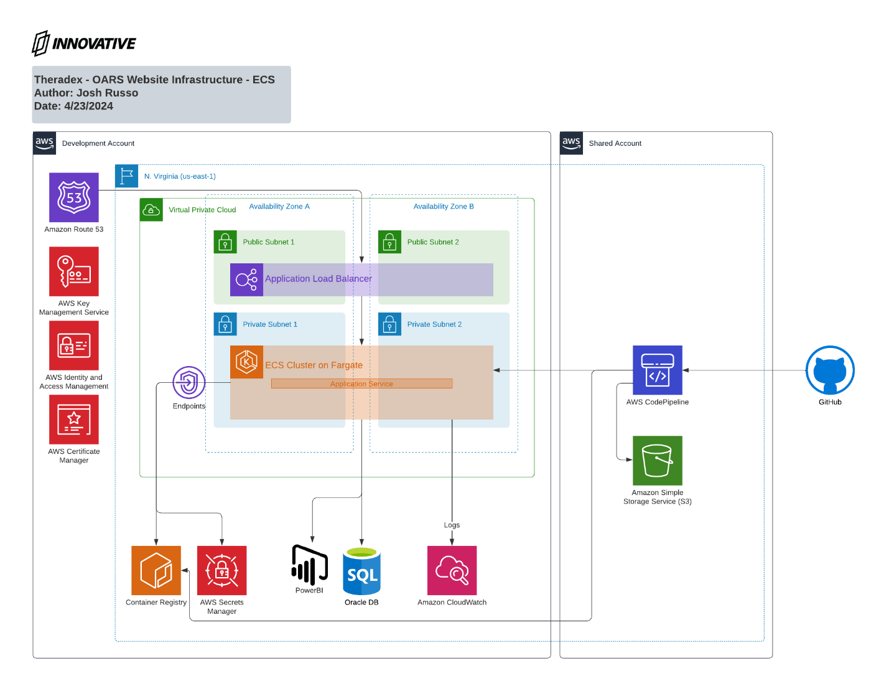

## DATABASE DESIGN Innovative

***Instructions:*** *Provide details in following areas as applicable:*

* *Logical Database design*
* *Entity Definitions*
* *Attribute Definitions*
* *Relationship Definitions*
* *Physical Database Design*
* *Data Model*
* *Table & Column Definitions*
* *Database View*

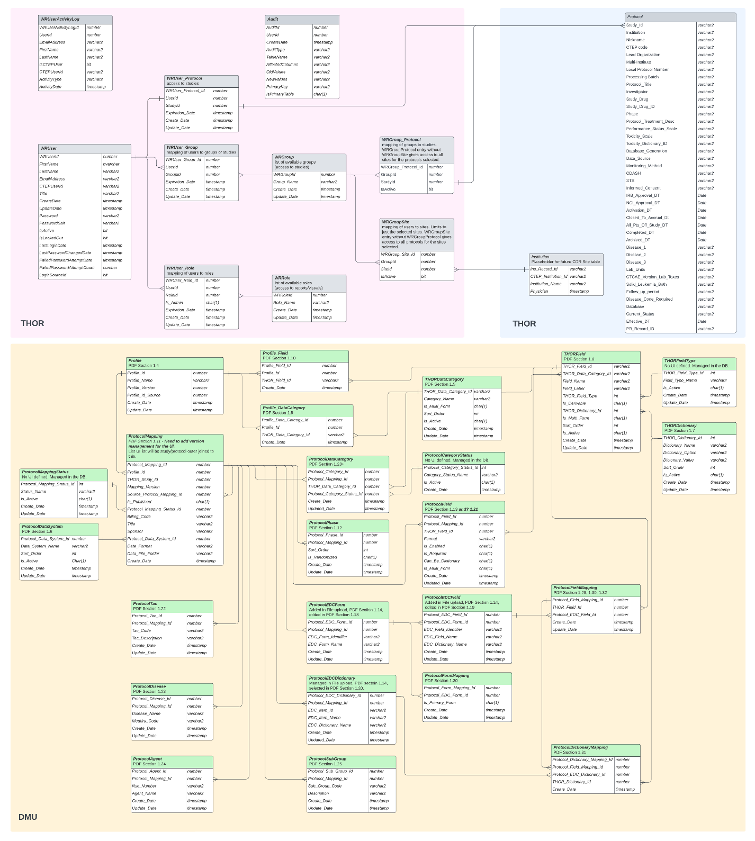

## SERVER HOSTNAMES Theradex

***Instructions:*** *Provide an overview of Server HostNames for each environment. Identify the Server HostNames(s) for applicable environments.*

## SYSTEM COMPONENTS & CUSTOMIZATION Innovative

***Instructions:*** *Identify the system software components (including version, any memory requirements) related to the system. Provide an overview of customization or enhancements to the software required to meet user requirements and functional specifications.*

Not applicable. The solution is completely custom and containerized.

## CONFIGURATION PARAMETERS Innovative

***Instructions:*** *Provide an overview of any configuration parameters outside the vendor default settings.*

Not applicable. The solution is completely custom and containerized.

## DIAGRAMS AND FLOW CHARTS Innovative

***Instructions:*** *Use diagrams (e.g., Flowcharts, sequence diagrams, Data Flow Diagrams) to illustrate the system design*

## USER INTERFACE (UI) DESIGN Innovative

***Instructions:*** *Describe the interfaces between systems both internal and external. Include any detailed integration effort.*

Build Protocol Mapping Study List Select Page

DMU Global Admin - New Profile Fields

DMU Study Mapping Edit

DMU Study Mapping

Global Admin 1

Global Admin 2

Global Admin 2 Thor Field Updated

Global Admin

Global Admin 3

Global Admin 4

Profile Edit

Protocol Mapping- Form Field Single

Protocol Mapping- Form Field Multi

Category List Select

Study Admin-Protocol Setup

Study Admin- CSV File Upload

Study Admin- File Selected

Study Admin- XML

Study Admin- EDC Forms

Study Admin- Fields

Study Admin- Dictionaries

Study Admin- Protocol TAC

Study Admin- Protocol Disease

Study Admin- Sub Group

Study Admin- Sub Group

Study Admin List

INTEGRATION ~~Innovative~~

***Instructions:*** *If the software will interact with other systems or components, describe the system integrations.*

Integrates with an Oracle database and Okta for authentication.

## ERROR HANDLING AND LOGGING ~~Innovative~~

***Instructions:*** *Describe how errors will be handled in the system, and how they will be logged for monitoring and debugging purposes.*

The DMU modules use the existing OARS error handling and logging patterns.

## REPORTS ~~Innovative~~

***Instructions:*** *Identify Reports that were developed/configured.*

No reports were developed.

## SECURITY ~~Innovative~~

***Instructions:*** *Provide an overview of any role-based security model that provides a way for administrators to control user and group access to objects that are under a defined security point within the object hierarchy according to the role the user or group is expected to perform within the system.*

The OARS application and by extension the DMU modules are protected by requiring an Okta login and the site is hosted using HTTPS.

## ~~DATABASE DESIGN DESCRIPTION Innovative~~

***~~Instructions:~~*** *~~Provide details in following areas as applicable:~~*

* *~~Logical Database design~~*
* *~~Entity Definitions~~*
* *~~Attribute Definitions~~*
* *~~Relationship Definitions~~*
* *~~Physical Database Design~~*
* *~~Data Model~~*
* *~~Table & Column Definitions~~*
* *~~Database View~~*

Duplicate of 4.3

# OTHER DESIGN DETAILS Innovative

## MULTI-BROWSER SUPPORT Innovative

***Instructions:*** *Provide an overview of various browsers that the system will support without loss of any functionality and applicable version numbers of each browser.*

The browser support is driven by the .NET Blazor framework. Microsoft documents .NET Blazor supporting the current versions of the following.

* Apple Safari
* Google Chrome
* Microsoft Edge
* Mozilla Firefox

The DMU modules have been tested on each.

***Other General Instructions on TD/CS Content:*** *Add sections/subsections for these as appropriate in the document. Innovative*

These don’t apply.

* + - *Hardware and software design details (including equipment and infrastructure components as applicable)*
    - *Continuous, discrete, advanced, and batch control*
    - *Interface data mapping and handshaking (considering user and automated interfaces to equipment, devices, instruments, or other systems, including any required reports)*
    - *Security configuration*
    - *Description of the processes, manipulations, and calculations that will be performed by the system*
    - *Definition of module (unit) parameters (inputs, outputs, internal, reporting)*
    - *Definition of logic flow or algorithms in word, tables, and diagrams*
    - *Definition of normal, error handling, and recovery logic*
    - *Design of the custom code, configuration and/or vendor customization to meet requirements*
    - *Any customizations or configurations to standard products*
    - *Backup and recovery design*
    - *I/O lists*
    - *Data archive*
    - *Data audit trail*
    - *Sequence of operations*
    - *Definition of environments (development, test, production, training)*
    - *Network topology/topography*
    - *Detailed System Architecture*
    - *Part 11 Compliance Design Controls*
    - *Graphic display*
    - *Interface data mapping*
    - *Hardware constraints (i.e., based on technology or configuration capabilities)*
    - *Alarm management*
    - *Environmental attributes (e.g., power, temperature, RH)*

# REFERENCES

***Instructions:*** *Identify any specific documents that were referenced in creation of this deliverable that includes document number and title.*

| Reference Identification | Description |
| --- | --- |
| THX #: 00-015 Computer System Software Development Life Cycle (SDLC) Policy | SDLC Policy |
| THX #: 03-180 Computer System SDLC Development Phase SOP | Computer System SDLC Development Phase SOP |